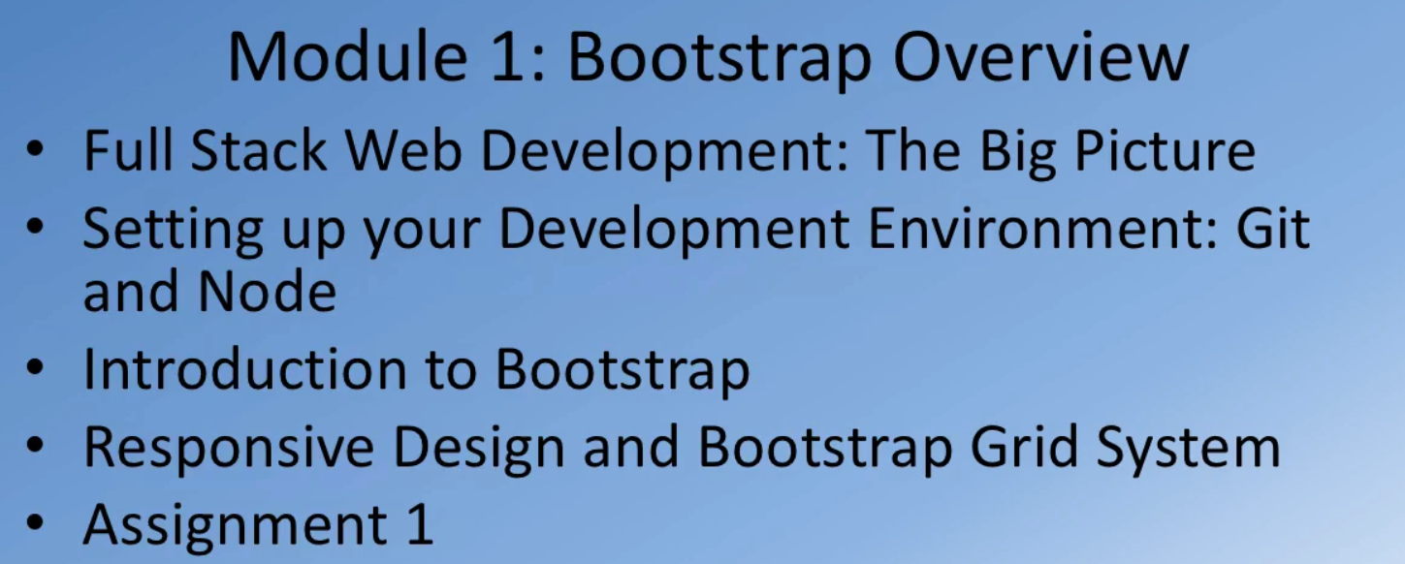

# Full Stack Web Development: The Big Picture

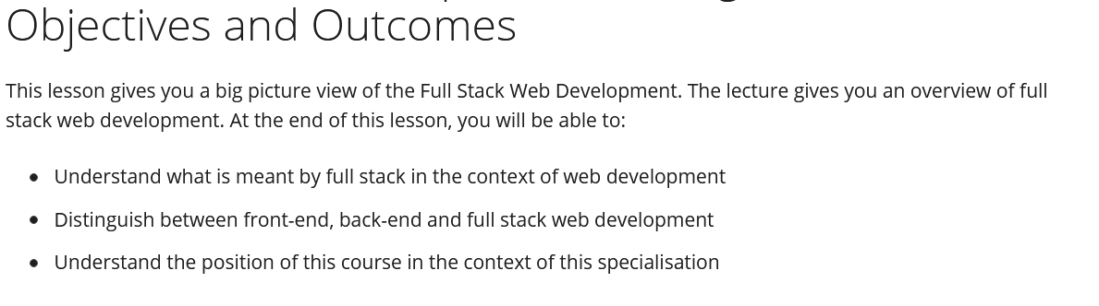

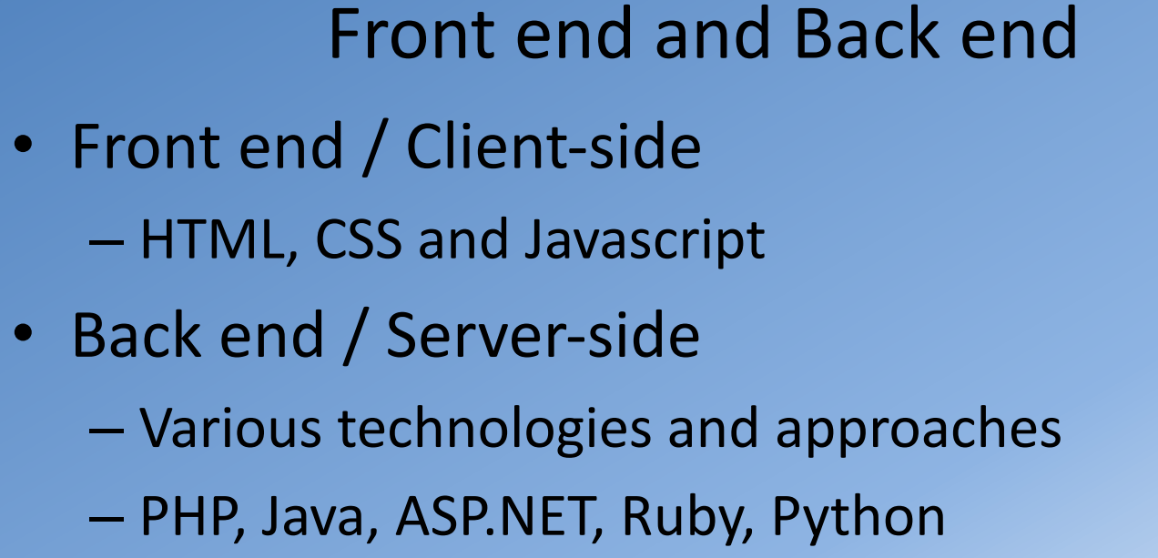

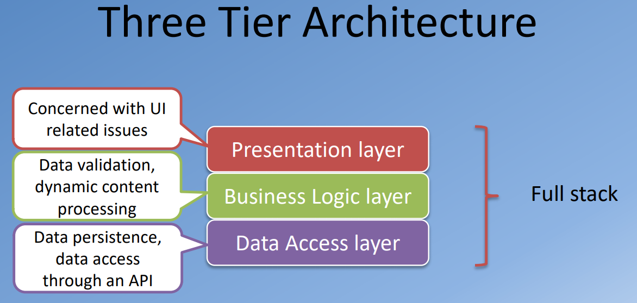

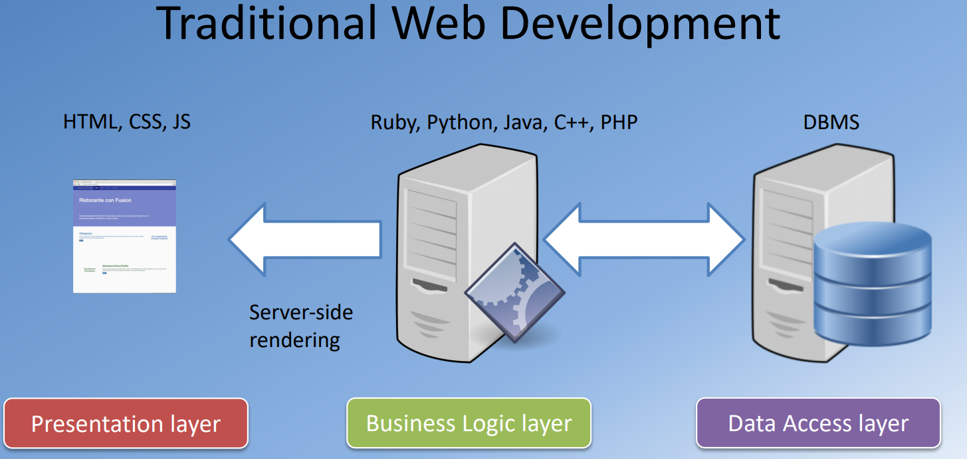

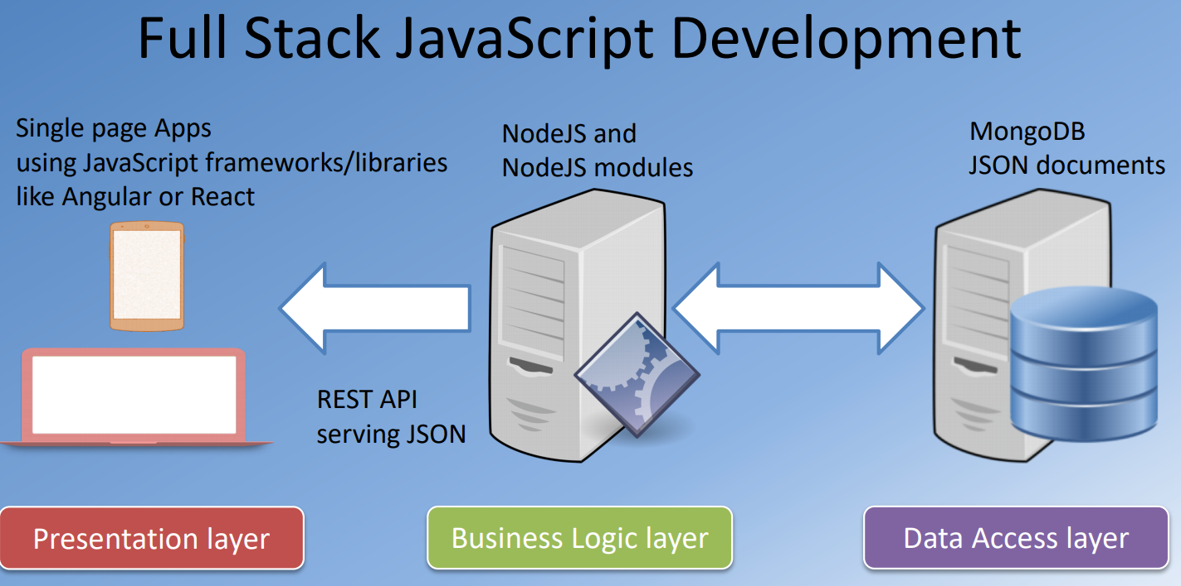

The entire web-development stack can be implemented using JavaScript.

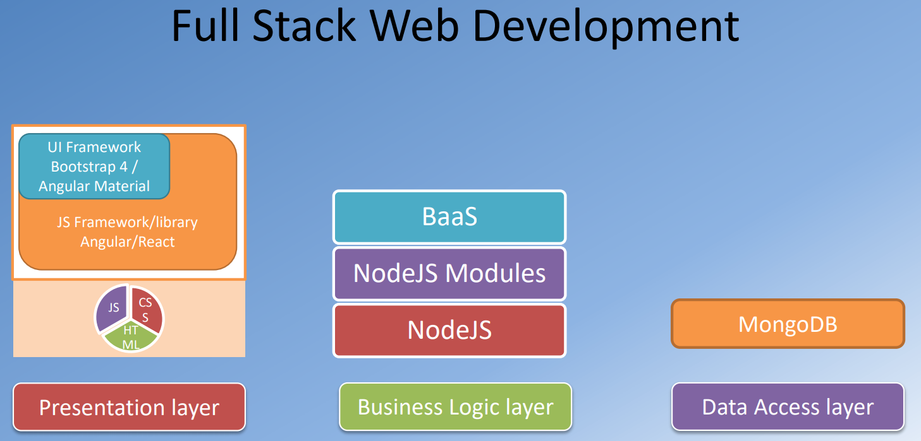

Readings:

[What is a Full Stack developer?](http://www.laurencegellert.com/2012/08/what-is-a-full-stack-developer/)  
<https://www.laurencegellert.com/2012/08/what-is-a-full-stack-developer/>

[Wait, Wait… What is a Full-stack Web Developer After All?](http://edward-designer.com/web/full-stack-web-developer/)  
<https://edward-designer.com/web/full-stack-web-developer/>

[The Myth of the Full-stack Developer](http://andyshora.com/full-stack-developers.html)  
<https://www.andyshora.com/full-stack-developers.html>

[Multi-tier Architecture](https://en.wikipedia.org/wiki/Multitier_architecture)  
<https://en.wikipedia.org/wiki/Multitier_architecture>

[What is the 3-Tier Architecture?](http://www.tonymarston.net/php-mysql/3-tier-architecture.html)  
<http://www.tonymarston.net/php-mysql/3-tier-architecture.html>

# Setting up Your Development Environment: Git and Node

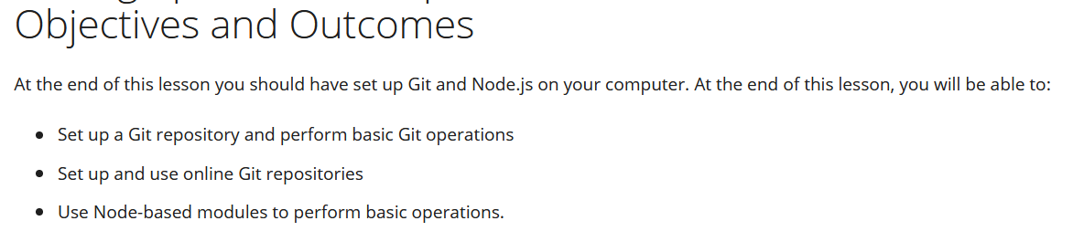

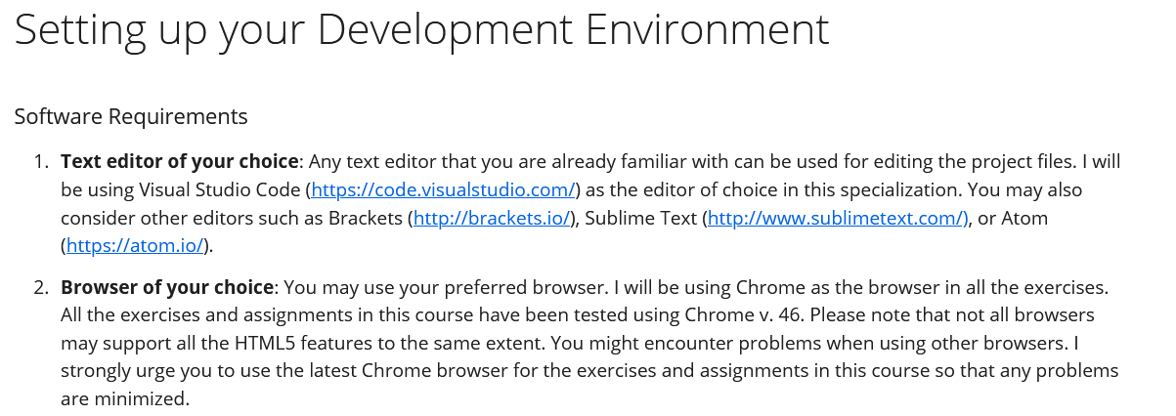  
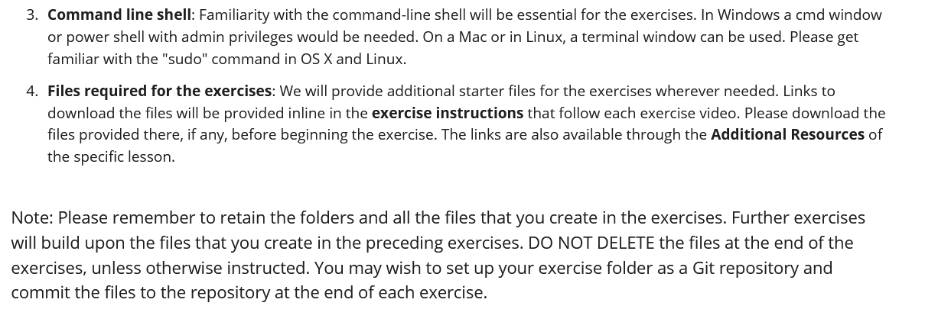

## **Git installation**

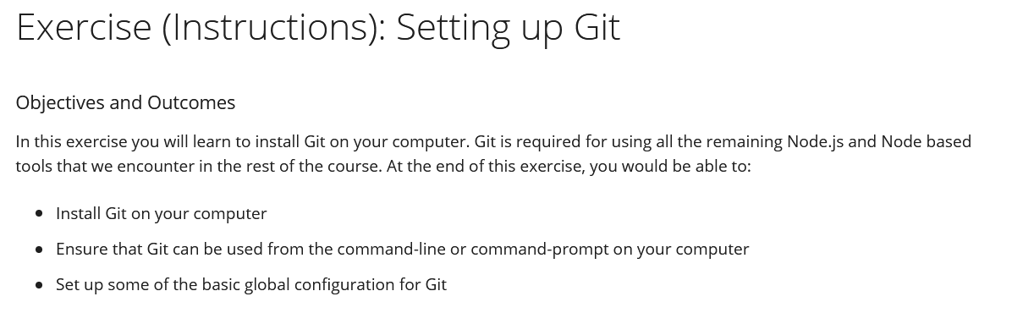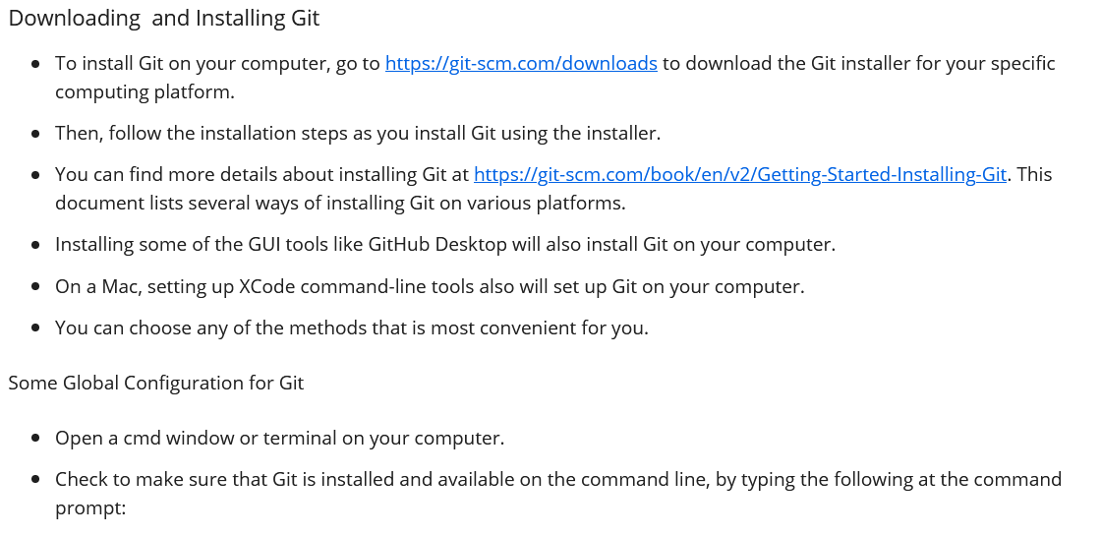

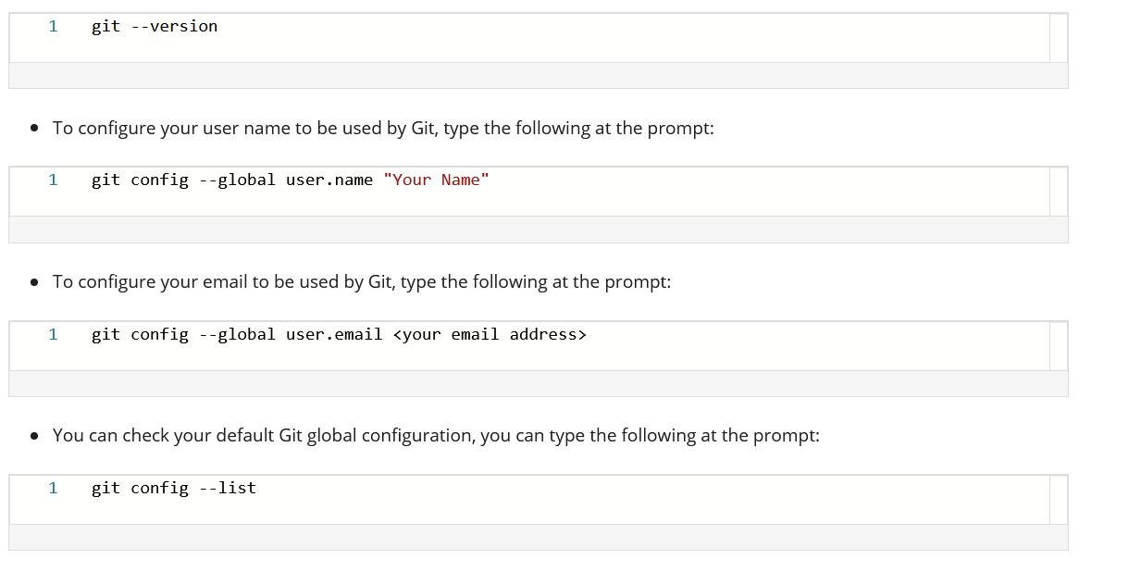

## **Setting up Local Git repository**

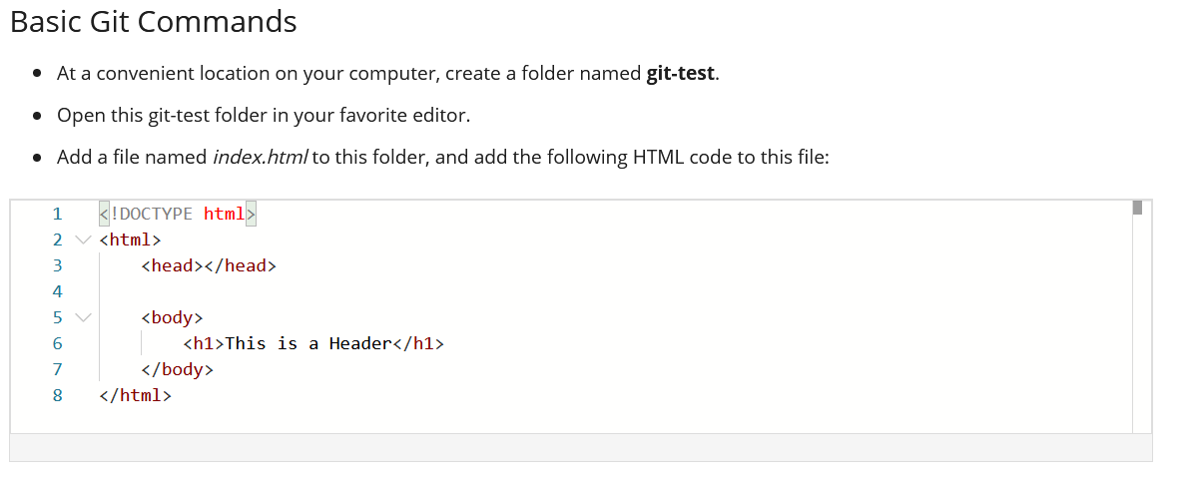 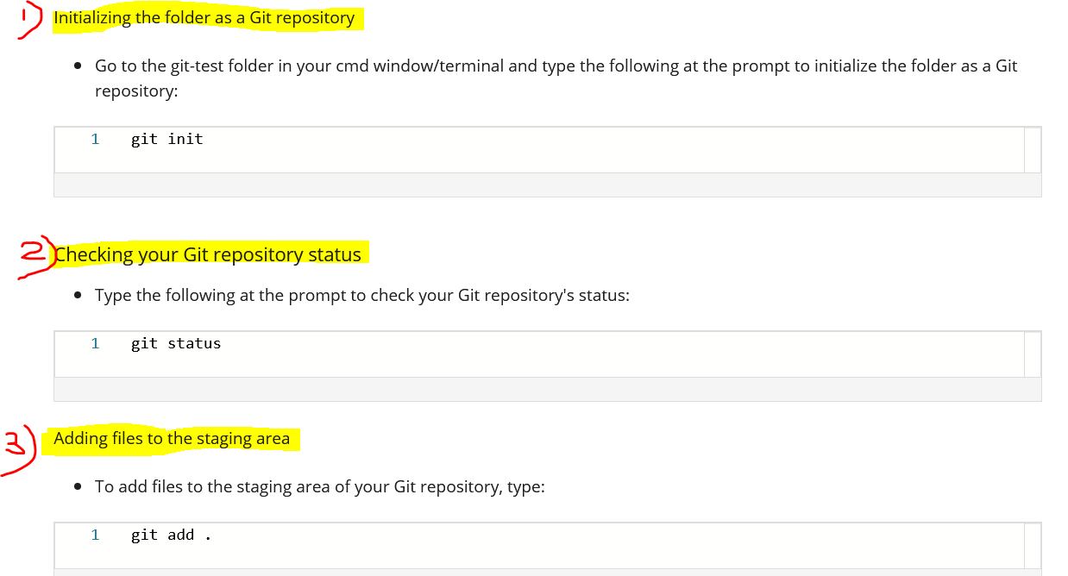

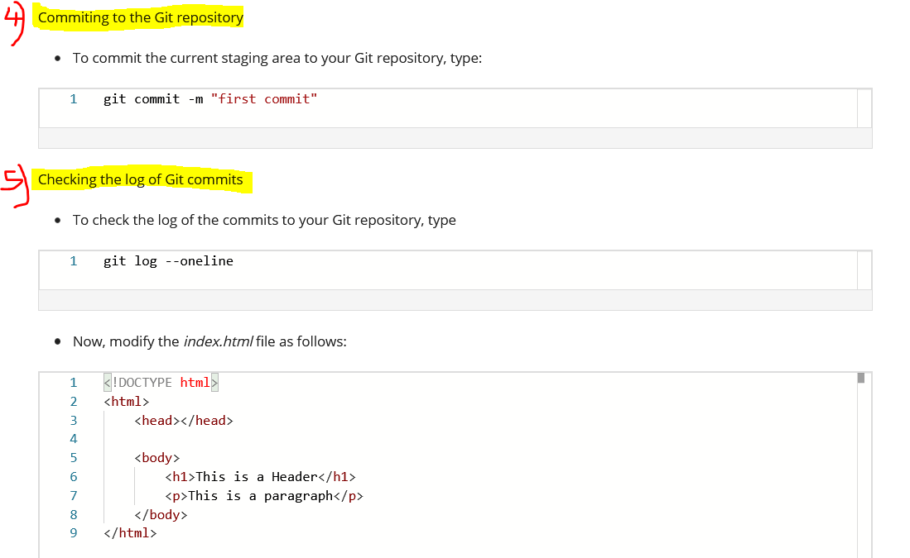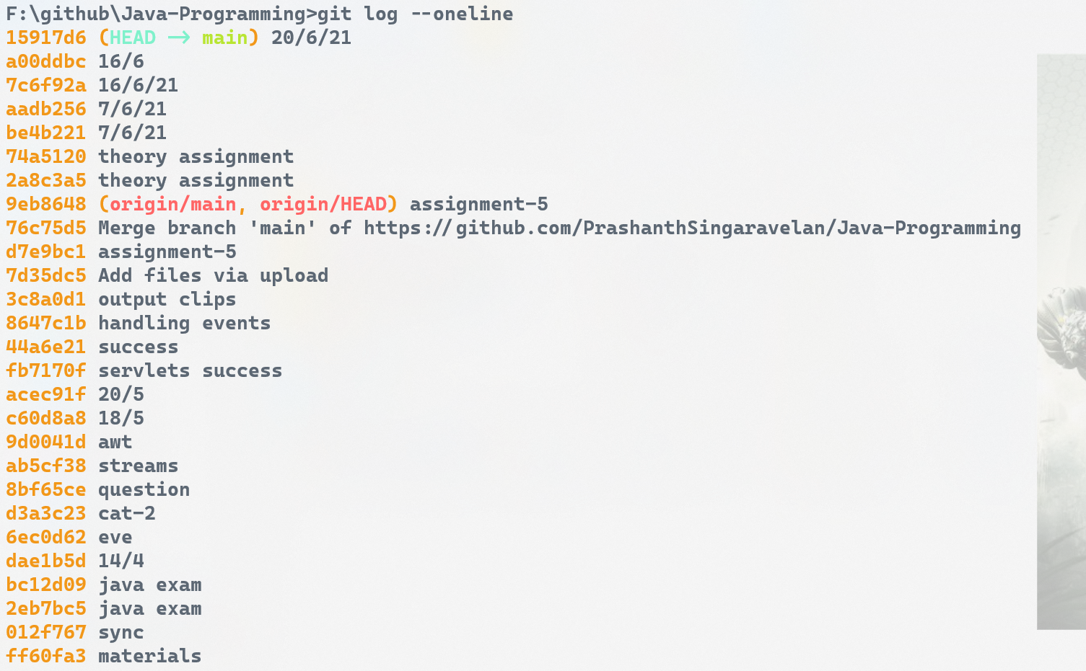

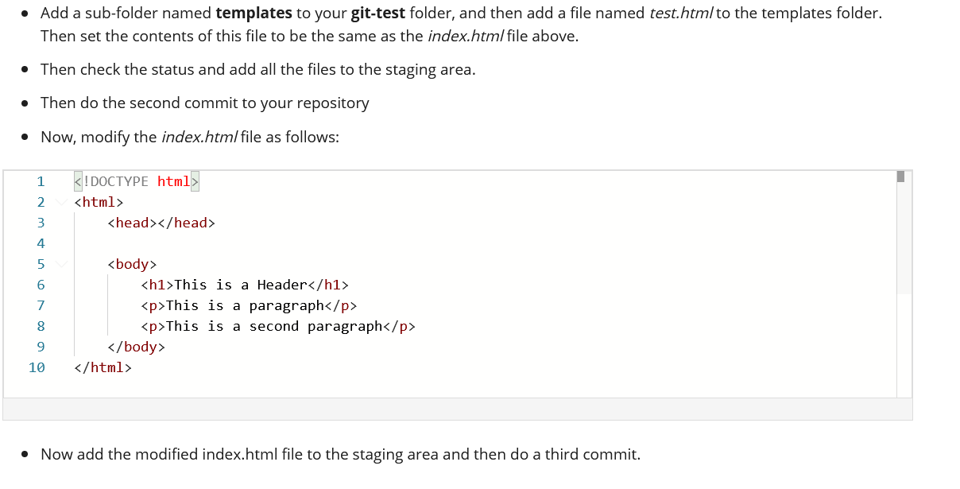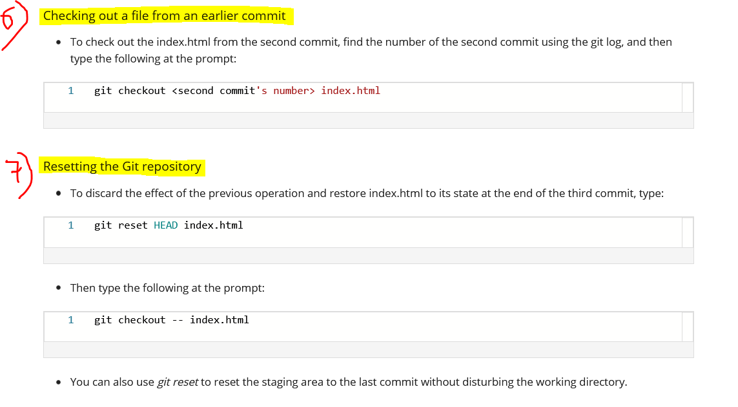

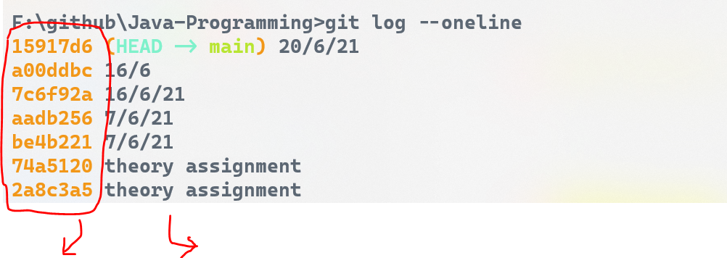

Commit number Commit message

If you made any changes in the file after the commit and you want to discard those changes, you can simply checkout the file from the last commit and then all your changes that you have done after the last commit will be discarded on the spot.

## **Setting up Online Git repository**

### **BitBucket**

1) Create a BitBucket account  
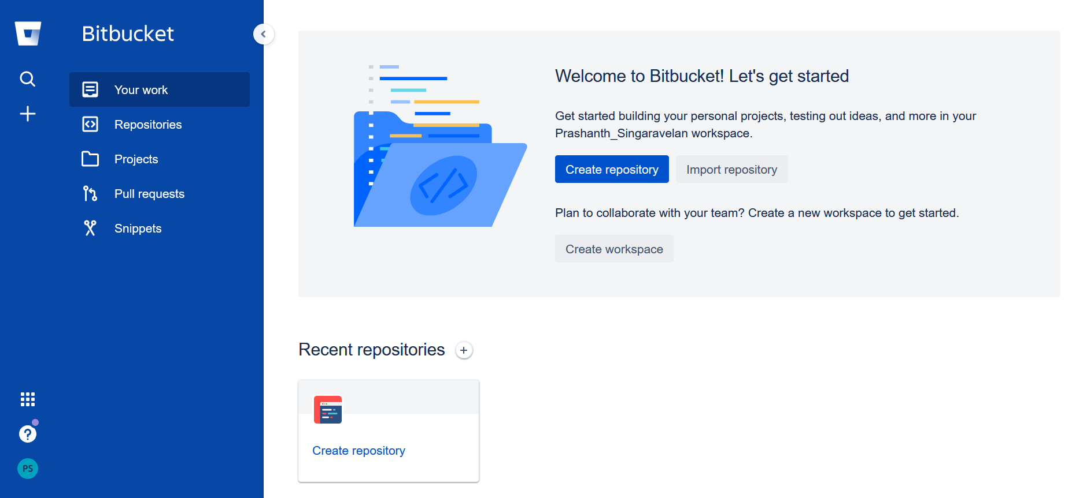

2) Create a new Repository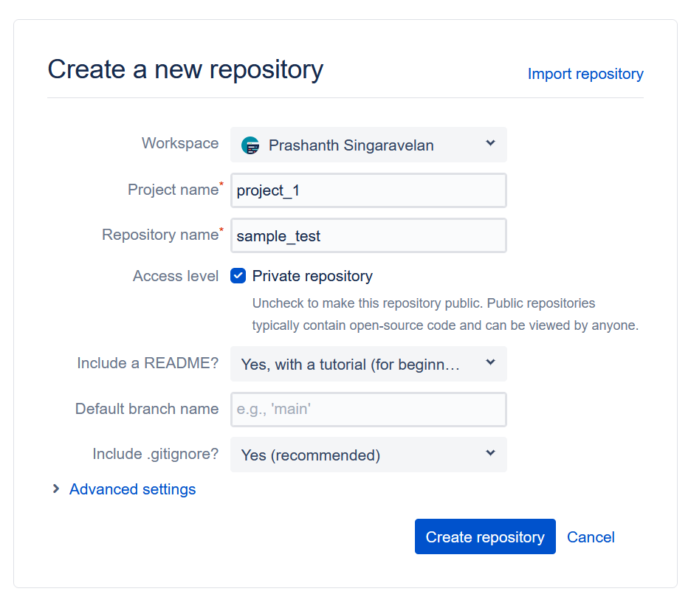

3) Click Clone

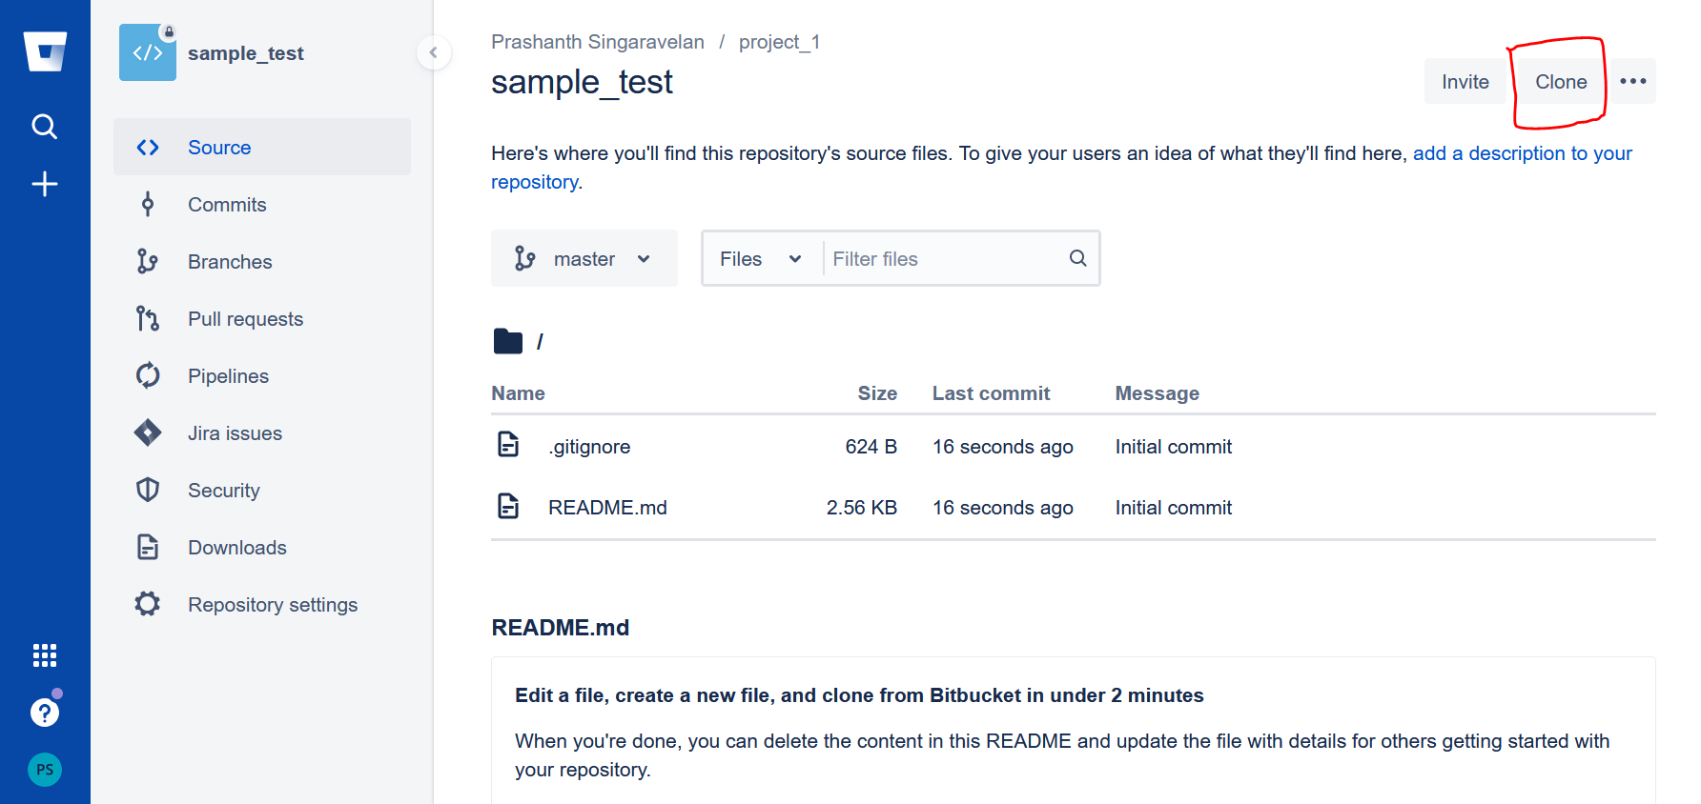

4) Copy the link

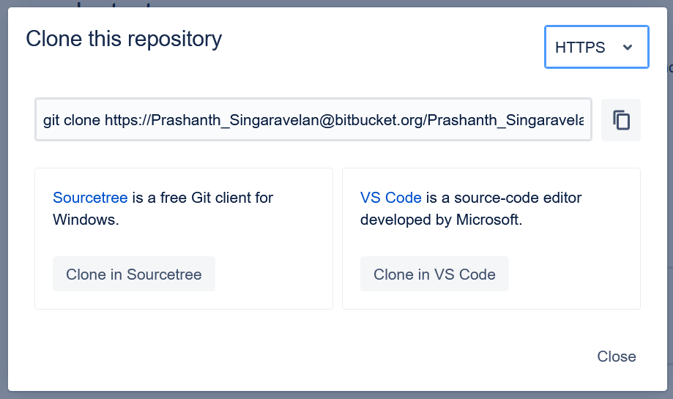

5) Creating a local git repository

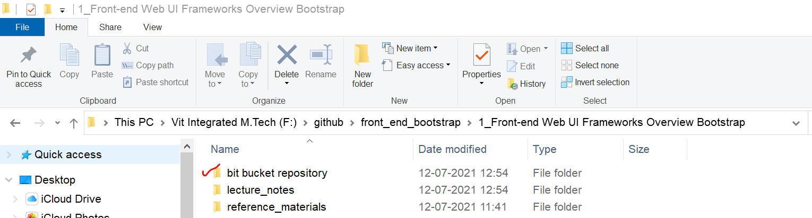  
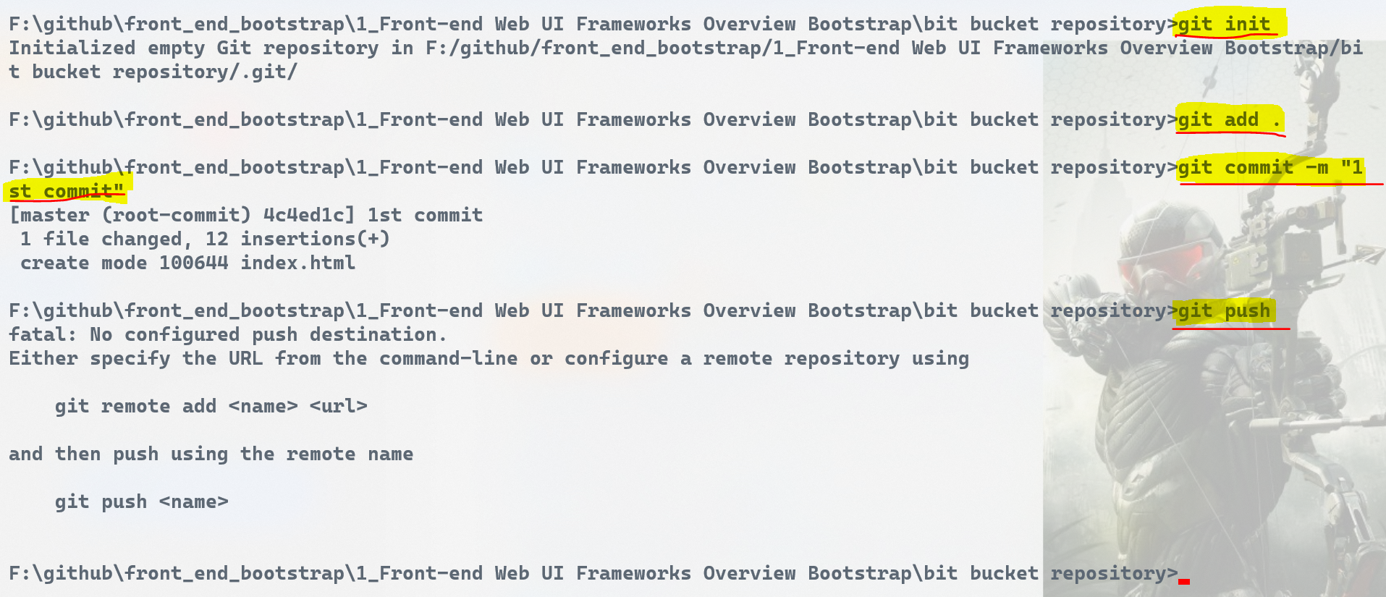  
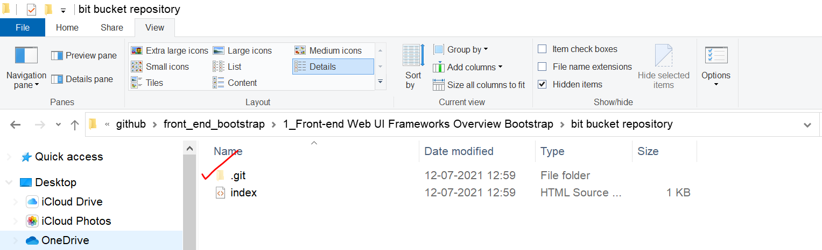

6) Connecting local git repository to the online git repository



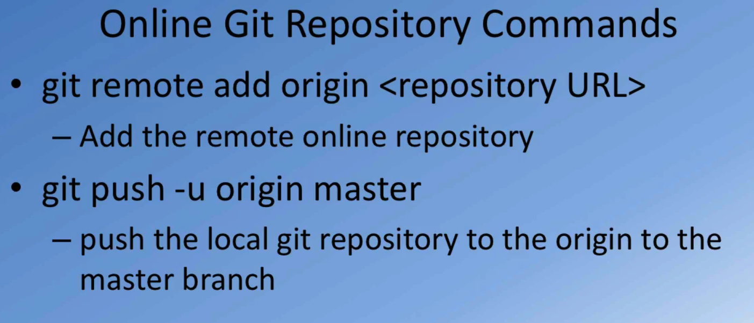

### **Github**